For many years over some centuries there has been a genre of dancing known as International Dancing. Distinct from ballroom or continental dancing, this genre grew up within the Balkans and spread into the Middle East.

Generally, each village within a valley would create (or use) a favorite piece of music and we suppose someone within this village would make up relatively simplistic steps to use with this music. An expert in international dancing would be that person who knew the various village favorites of a country or several countries.

One of the lands included above was Palestine prior to 1948. About 10% of the traditional international repertoire is made up of dances created in Palestine (and later Israel) up to the late 1950s. However, the arts were evolving in Israel. The steps to newly created dances became faster and more advanced to go with the increased complexity of the music. By the late 1950s the consensus was that the popular dances created contemporaneously were moving into another genre – now known as Israeli dancing.

The Israeli dance repertoire consists of over 8,000 separate dances, each with a unique set of steps. Since the 1990s, in an attempt to standardize the steps to specific dances, the government of Israel requires a choreographer to explain his/her steps to a specific piece of music – a sort of choreographed thesis – to have these steps become officially connected with that specific piece of music.

We all hope you will enjoy our demonstration!

***Background on a few of the dances you may see this afternoon:***

**Shir Al Etz (Yiddish) *On the Road***

[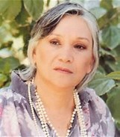](https://www.bing.com/images/search?q=%22naomi+shemer&FORM=IARRTH&ufn=naomi+shemer&stid=6fc5dbbd-d65a-9c19-1cc6-79050b40cdae&cbn=EntityAnswer&cbi=0&FORM=IARRTH)Choreographer: Jonathan Gabay; Lyricist: [Naomi Shemer](http://hebrewsongs.com/artist.asp?name=naomishemer) (pictured); Music: Shmuel Fischer; Singer: [HaGevatron](http://www.hebrewsongs.com/artist.asp?name=gevatron)

Naomi Shemer is one of the great Israeli lyricists (and musicians). Her song, "Jerusalem of Gold," was the theme song for the 50th anniversary Israel celebrations in 1998.

**Adon Olam (French) *Master of the Universe***

Choreographer: Gadi Bitton (2010); Lyricist: Mekorot; Music: Shlomo Aqua;   
Singer: [Daklon](http://www.hebrewsongs.com/artists-daklon.htm)

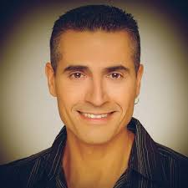Jewish prayers (and ceremonial music) are frequently used in Israeli dance. In this example, the music has a more modern sound. The choreographer, Gadi Bitton (pictured), is very famous in Israeli dance circles.

**Chibuk Bachashecha (Greek) *Darkness Hugs Me***

Choreographer: Oren Ashkenazi (2007); Lyricist and Singer: Helena Paparizou

For most of the Philadelphia dance contingent at this afternoon’s session, this dance brings back memories of the Machol Yam 2014 cruise when this dance was taught by the choreographer. Yes, like many hobbies and interests, Israeli dance workshops are sometimes held on cruise ships such as the Liberty Of The Seas (pictured). The vast majority of dance workshops, however, are held on land, in auditoriums and gymnasiums around the world.

**Avre Tu (Ladino) *Open Your Door***

Choreographer: Roni Siman Tov (1983); Lyricist: Itzchak Levi; Singer: [Haparvarim](http://www.hebrewsongs.com/artists-theparvarim.htm)

Yiddish is a combination of Hebrew and German. In a similar manner, Ladino is a combination of Spanish and Hebrew. This was a prevalent language at one time of the Sephardic Jews. Much of the Israeli dance repertoire is in languages other than Hebrew, giving this dance genre a cosmopolitan feel.

**El Elohai Shamayim (Russian?) *G-d Master of the Universe***

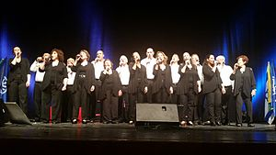Choreographer: Avner Naim (1995); Lyricist: Dudu Barak; Music: Mikis Theodorakis; Singer: [HaGevatron](http://www.hebrewsongs.com/artist.asp?name=gevatron) (pictured)

[HaGevatron](http://www.hebrewsongs.com/artist.asp?name=gevatron) (aka Gevaston), a group established in the late '40s whose origins date back to a specific kibbutz, is referenced several times today. While the original singers have been replaced, the group continues to perform.

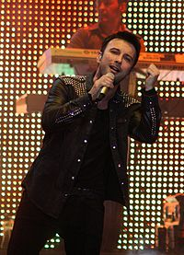**Nishika Turkit (Turkish) *Turkish Kiss***

Choreographer: Meir Shem Tov (1997); Lyricist: Sezen Aksu; Singer: Tarkan Tevetoglu

This singer (pictured) is known in Europe just as Tartan. For the last 25 years, since the creation of his first album, his name has evoked an aura in Turkey similar to the one Elvis created in this country.

**Salamati (Persian) *Cheers***

Choreographer: Gadi Bitton (2005); Singer: Arash (2005)

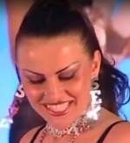The singer Arash (pictured), born in Iran, emigrated with his family to Finland. Several   
of his songs are in the Israeli dance repertoire, and they are always fun to perform! He fuses the long tradition of Persian music with the pop tempo found in European music. You can hear the full, original version of this song (with a cute dramatization) at http://www.youtube.com/watch?v=xYAnhVURJlU

**Shuj Shuj Zemer (Albanian) *Hush Hush Heart***

Choreographer: Ira Weisburd (2005); Lyricist, Music, Singer: [Gjyste Vulaj](http://www.korcaonline.com/Vulaj.htm) (pictured)

[Gjyste Vulaj](http://www.korcaonline.com/Vulaj.htm) is a famed female Albanian singer. But her talents go far beyond her voice as Vulaj also did the music and lyrics for this song. Weisburd, the choreographer, has choreographed 15 Israeli dances throughout the years. But he is more famous for his line dance choreography which has earned him many awards.

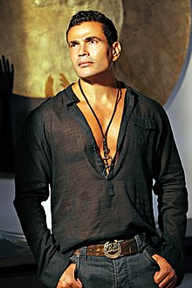**Amarine (Arabic) *Twin Moons***

Choreographer: Avi Levy(in 2002); Lyrics and Singer:Am[a]r Diab (pictured)

A significant portion of the music used in Israeli dance is of foreign origin (non Israeli) and some from Israel’s neighbors. In many cases the lyrics (and singer) are changed. In this case, the original music (a hit throughout the Arab world) and singer has been used.

**Eshebo (Algerian) *Beautiful***

Choreographer: Beber Shushanin (1991); Lyricist: Ibrahim Chalad; Singer: [Etti Ankri](http://www.hebrewsongs.com/artists-ettiankri.htm)

You can hear the Middle East influence in the beat of this music. The Israeli dance steps are also quite interesting – seeming to be almost International – and they go well with the music.

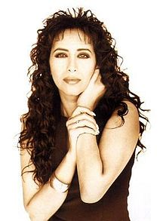**Behar Hagilboa (Hebrew) *On Mt. Gilboa***

Choreographer: Sefi Aviv (1986); Lyricist: Leah Naor; Music: Yosef Hadar; Singer: [Ofra Haza](http://www.hebrewsongs.com/artists-ofrahaza.htm)

Mt. Gilboa is a prominent geographical point in Israel. Another prominent feature of this song is Ofra Haza (pictured), born in Israel (in 1957) of Yemenite parents. Although Haza died prematurely at the age of 42, her remarkable voice still is remembered throughout the Middle East where she is considered one of the great vocalists of all time.

**Hine Ma Tov(Hebrew) *How Good It Is***

Choreographer:Silvio Berlfein(in 2000); Music:Moshe Jacobson; Singer:The Miami Boys Choir

Isaraeli dance is broken down into several subsets: circle, lines and partners. This dance, with Turkish Kiss, are two line dances with the other dances being circles. Line dances are broken down into how many walls dancers face at the start of each iteration of the dance. Most popular line dances – think of the Alley Cat or the Soul City Walk – are set at 4 meaning that each dancer makes a quarter turn for each iteration. The line dances indicated in this documentation are classified as 1 wall.